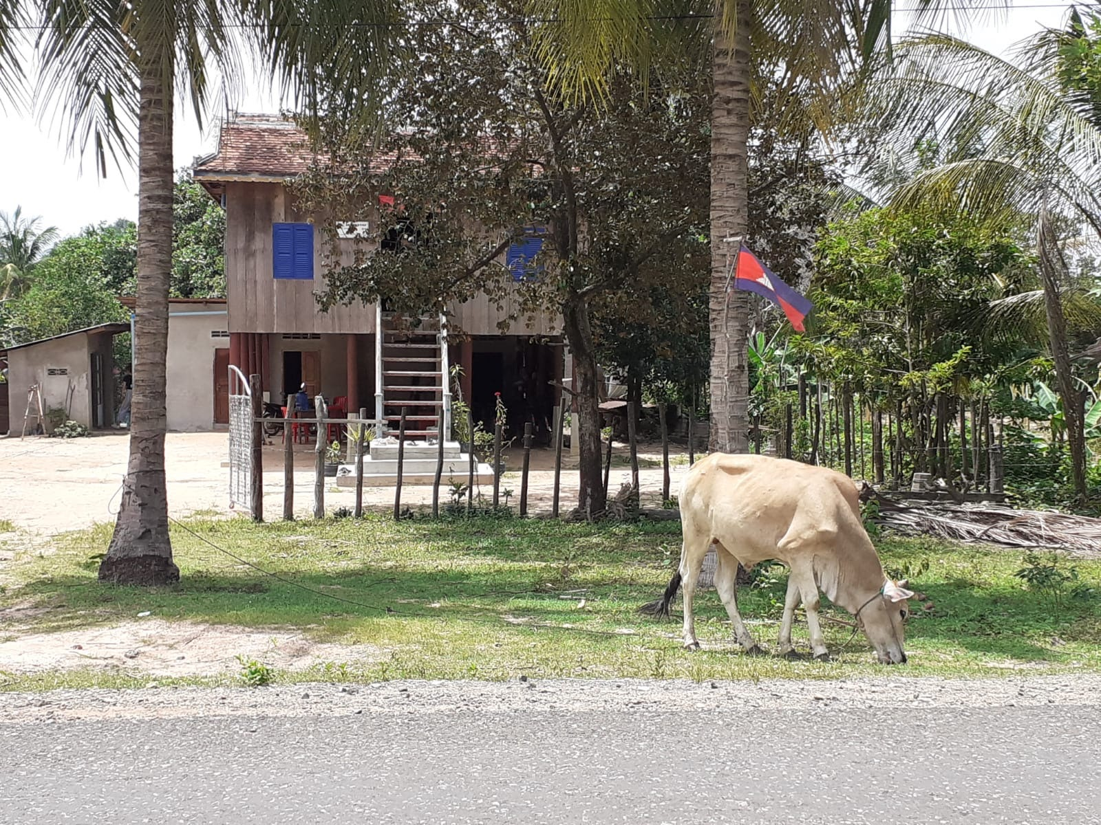
What do you noticed about this traditional Cambodian house?
………………………………………….………………………………………….………………………………………….………………………………………….………………………………………….………………………………………….………………………………………….………………………………………….………………………………………….………………………………………….………………………………………….………………………………………….………………………………………….………………………………………….………………………………………….………………………………………….………………………………………….………………………………………….………………………………………….………………………………………….………………………………………….………………………………………….………………………………………….………………………………………….………………………………………….…………….

What are the differences in the outside of the houses?
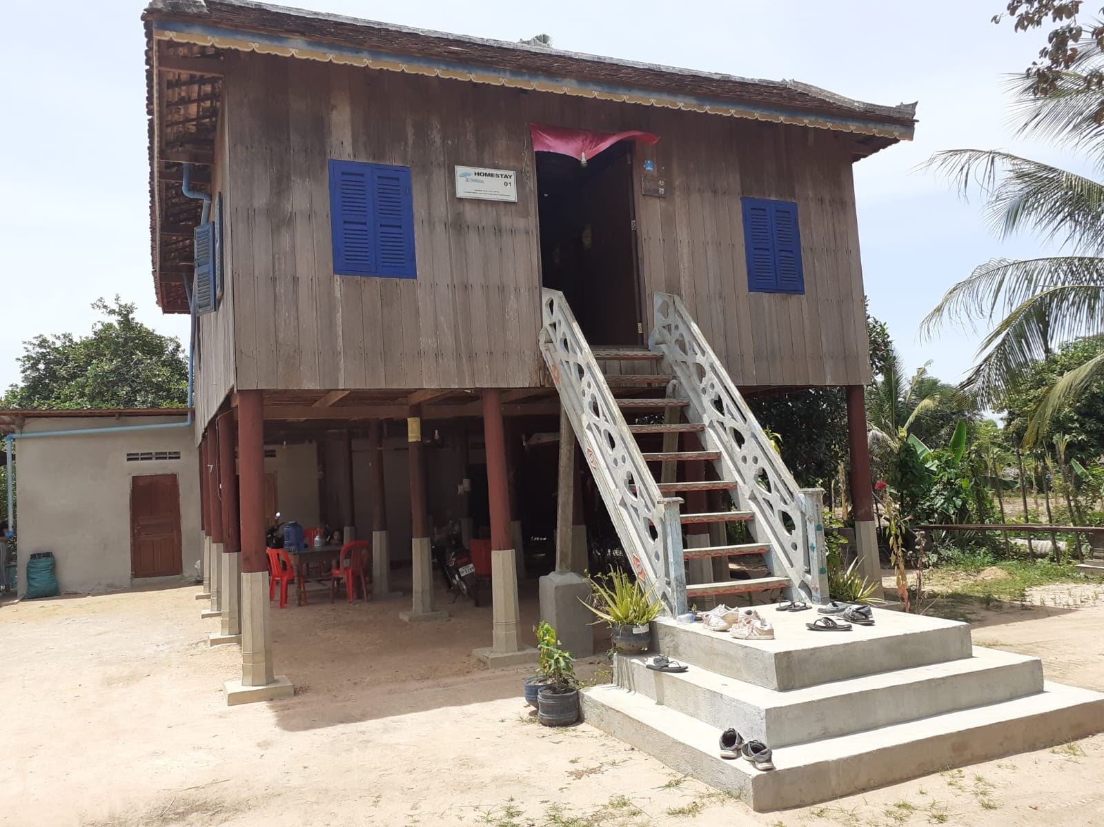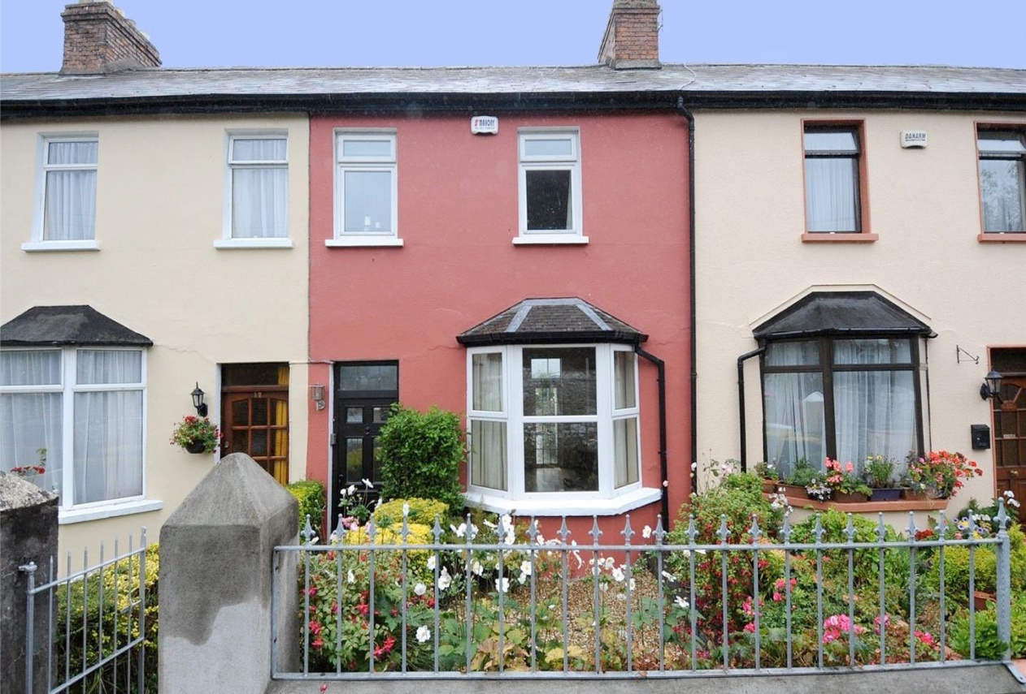

What are the Similarities in the outside of the houses?

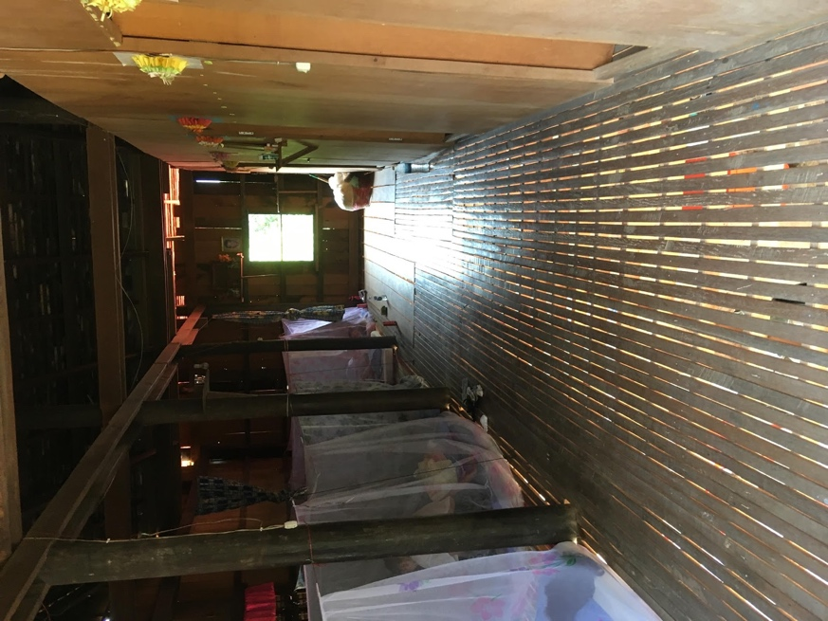
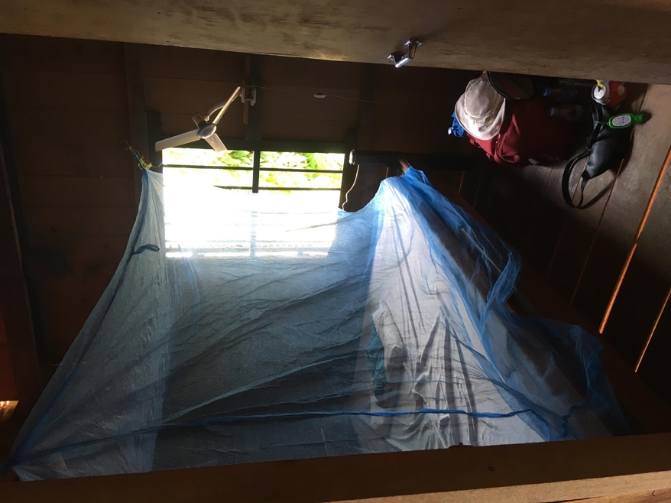
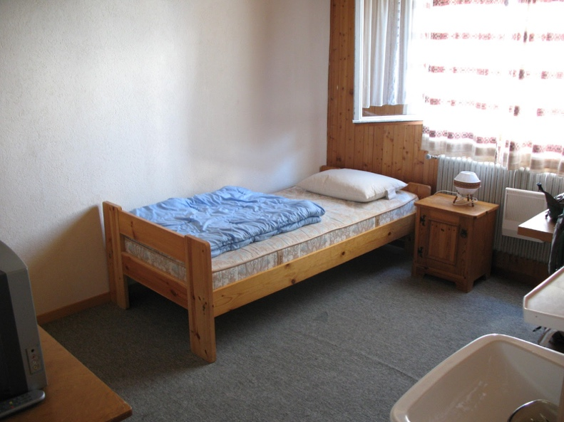
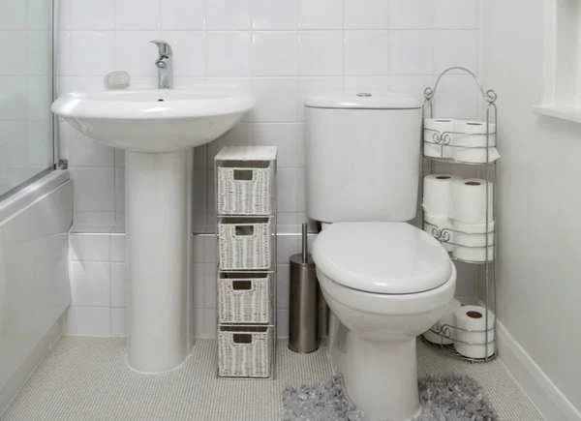
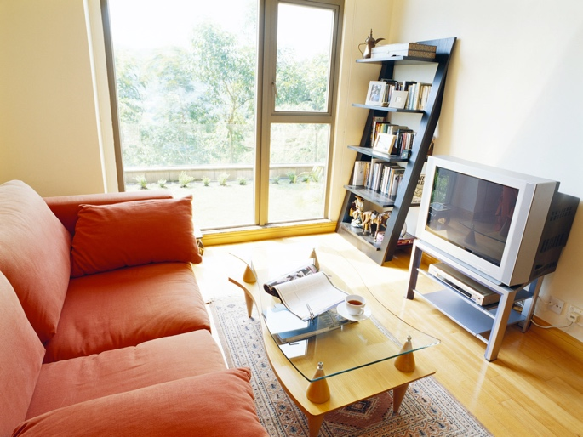
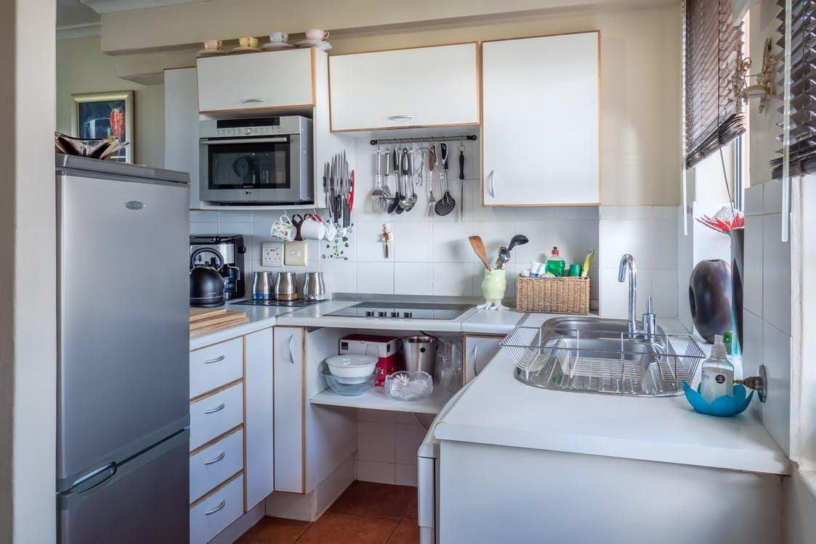
What are the differences in the inside of the houses?
What are the Similarities in the inside of the houses?

